

|  |
| --- |
| HCL Technologies Ltd. |
| **Blue Button – Format of Health Record** |
|  |

# Overview

The Blue Button is a tool to make patient medical records easily available for patients to download and share with members of their health care team. The tool is an electronic health record that keeps a digital record of clinical information about a particular individual. With the amount of variability among Health IT systems, it is important to have a consistent set of health information for each patient. Developers can also find ways to integrate Blue Button tool to leverage user’s medical record.

**Key points:**

1. Blue button stores the medical record of any individual registered in it.
2. The medical record of a person is kept in a XML file.
3. Blue button follow a XML- based standard to represent the patient health record.
4. Standard is [**HL7 Consolidated Clinical Document Architecture**](http://www.hl7.org/implement/standards/product_brief.cfm?product_id=258) also known as the Consolidated CDA (CCDA).
5. Sections

All CCDA generated for a patient, include all the following sections –

|  |  |  |
| --- | --- | --- |
| **No.** | **Section** | **Description** |
| **1** | **Header** | Patient information and demographics |
| **2** | **Allergies, Adverse Reactions, and Alerts** | Includes status and severity of each. |
| **3** | **Encounters** | Surgeries, ED visits, etc. |
| **4** | **Immunizations** | Immunizations and vaccines |
| **5** | **Medications** | As prescribed by the provider |
| **6** | **Care Plan** | Planned activities and encounters |
| **7** | **Discharge Medications** | Part of hospital discharge summary |
| **8** | **Reason for Referral** | Written reason for referral |
| **9** | **Problem List** | Concerns, complaints, and observations |
| **10** | **Procedures** | History of procedures |
| **11** | **Functional and Cognitive Status** | List of impairments |
| **12** | **Results** | Includes laboratory tests |
| **13** | **Social History** | Observations like smoking, drinking, etc. |
| **14** | **Vital Signs** | Includes height, weight, blood pressure, etc. |
| **15** | **Discharge Instructions** | Written discharge instructions |

# CDA Document Structure

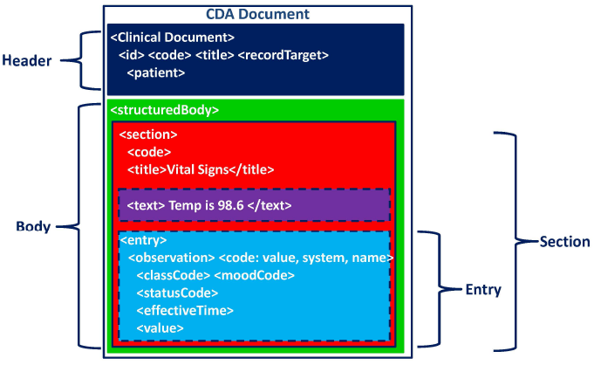

## Breakdown of CCDA XML

1. CDA document broadly divided in two sections –
   1. Header
   2. Body
2. XML Declaration

***<?xml version="1.0"?>***

***<?xml-stylesheet type="text/xsl" href="CDA.xsl"?>***

<ClinicalDocument xmlns:xsi="http://www.w3.org/2001/XMLSchema-instance"

xsi:schemaLocation="urn:hl7-org:v3 ../../../CDA%20R2/cda-schemas-and-samples/infrastructure/cda/CDA.xsd" xmlns="urn:hl7-org:v3" xmlns:cda="urn:hl7-org:v3" xmlns:sdtc="urn:hl7-org:sdtc">

* For human readability, XSLT stylesheet is included, as follows :

***<?xml-stylesheet type="text/xsl" href="CDA.xsl"?>***

* XML references the schema from HL7 and follows Clinical Document Architecture

<ClinicalDocument xmlns:xsi="http://www.w3.org/2001/XMLSchema-instance" xsi:schemaLocation="urn:hl7-org:v3 ../../../CDA%20R2/cda-schemas-and-samples/infrastructure/cda/CDA.xsd" xmlns="urn:hl7-org:v3" xmlns:cda="urn:hl7-org:v3" xmlns:sdtc="urn:hl7-org:sdtc">

1. Header

This is the first part of the file. It includes the following

* Personal detail of the patient – name, address, birth time, gender, guardian & their address etc.
* Creator of XML document
* Main tag “<recordTarget>”

Tree structure for patient information given below:

1. recordTarget
   1. patientRole
      1. id
      2. addr
         1. streetAddressLine
         2. city
         3. state
         4. postalCode
         5. country
      3. telecom
      4. patient
         1. name
            1. given
            2. family
         2. administrativeGenderCode
         3. birthTime
         4. maritalStatusCode
         5. religiousAffiliationCode
         6. raceCode
         7. ethnicGroupCode
         8. guardian
            1. code
            2. addr

streetAddressLine

city

state

postalCode

country

* + - * 1. telecom
        2. guardianPerson

name

given

family

* + - 1. birthplace
         1. place

addr

city

state

postalCode

country

* + - 1. languageCommunication
         1. languageCode
         2. modeCode
         3. preferenceInd
    1. providerOrganization
       1. id
       2. name
       3. telecom
       4. addr
          1. streetAddressLine
          2. city
          3. state
          4. postalCode
          5. country

**Tree structure for creator (and other) information is as below**

1. author
   1. time
   2. assignedAuthor
      1. id
      2. addr
         1. streetAddressLine
         2. city
         3. state
         4. postalCode
         5. country
      3. telecom
      4. assignedPerson
         1. name
            1. prefix
            2. given
            3. family
2. dataEnterer
   1. assignedEntity
      1. id
      2. addr
         1. streetAddressLine
         2. city
         3. state
         4. postalCode
         5. country
      3. telecom
      4. assignedPerson
         1. name
            1. given
            2. family
3. informant
   1. assignedEntity
      1. id
      2. addr
         1. streetAddressLine
         2. city
         3. state
         4. postalCode
         5. country
      3. telecom
      4. assignedPerson
         1. name
            1. given
            2. family
   2. relatedEntity
      1. code
      2. relatedPerson
         1. name
            1. given
            2. family
4. custodian
   1. assignedCustodian
      1. representedCustodianOrganization
         1. id
         2. name
         3. telecom
         4. addr
            1. streetAddressLine
            2. city
            3. state
            4. postalCode
            5. country
5. informationRecipient
   1. intendedRecipient
      1. informationRecipient
         1. name
            1. given
            2. family
         2. receivedOrganization
            1. name
6. legalAuthenticator
   1. time
   2. signatureCode
   3. assignedEntity
      1. id
      2. addr
         1. streetAddressLine
         2. city
         3. state
         4. postalCode
         5. country
      3. telecom
      4. assignedPerson
         1. name
            1. given
            2. family
7. authenticator
   1. time
   2. signatureCode
   3. assignedEntity
      1. id
      2. addr
         1. streetAddressLine
         2. city
         3. state
         4. postalCode
         5. country
      3. telecom
      4. assignedPerson
         1. name
            1. given
            2. family
8. participant(2)
   1. associatedEntity
      1. code
      2. addr
         1. streetAddressLine
         2. city
         3. state
         4. postalCode
         5. country
      3. telecom
      4. associatedPerson
         1. name
            1. prefix
            2. given
            3. family
9. Body

All other sections are defined in body. Body starts as follows:

*<!-- \*\*\*\*\*\*\*\*\*\*\*\*\*\*\*\*\*\*\*\*\*\*\*\*\*\*\*\*\*\*\*\*\*\*\*\*\*\*\*\*\*\*\*\*\*\*\*\*\*\*\*\*\*\*\*\**

*CDA Body*

*\*\*\*\*\*\*\*\*\*\*\*\*\*\*\*\*\*\*\*\*\*\*\*\*\*\*\*\*\*\*\*\*\*\*\*\*\*\*\*\*\*\*\*\*\*\*\*\*\*\*\*\*\*\*\*\* -->*

<component>

<structuredBody>

*<!-- *********************** -->*

All sections are defined inside below structure:

<component><section>……….</section></component>

Each section has three main parts :

* title – Title of the section
* text – all human - readable part of the section
* entry – content or detail for further computer processing

Tree structure is as below:

1. component
   1. structuredBody
      1. component
         1. section
            1. templateId
            2. code
            3. title
            4. text
            5. entry

act

# Reference

<http://bluebuttonplus.org/healthrecords.html>

<http://www.va.gov/bluebutton/>